**Project 5 Part 3 Canny Edge Detection Complete**

Name: Vivian Feng Period: 5 Date: 1/20/2023

Is your lab name l053?(lowercase L followed by digits 053) Yes

**Did you test your code on a school terminal using c++11?** Yes

(you compile like this: g++ -std=c++11 -Wall -o l052 l052.cpp)

Does your main method call only part3()? Yes

Did you create a gray image? Yes

Did you apply the Sobell operator? Yes

Did you apply a double threshold/hysteresis? Yes

Did you apply non-max suppression? Yes

Did you test using command line arguments? Yes

Paste here **5 clear pictures** of the initial picture (image.ppm), the grey image (imageg.ppm), the image obtained after applying hysteresis & double threshold (image1.ppm), the image you obtained after applying non-maximum suppression (image2.ppm), the image obtained after applying both (imagef.ppm):

image:

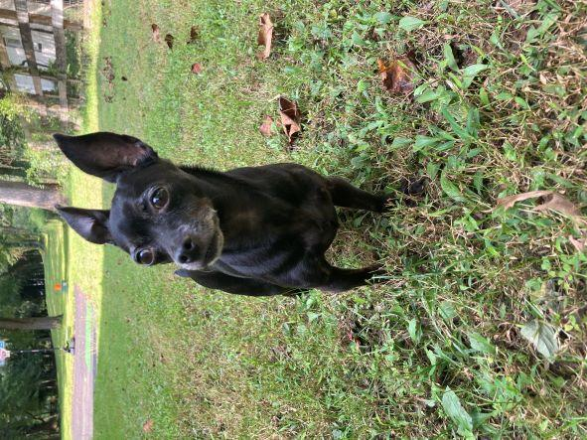

imageg:

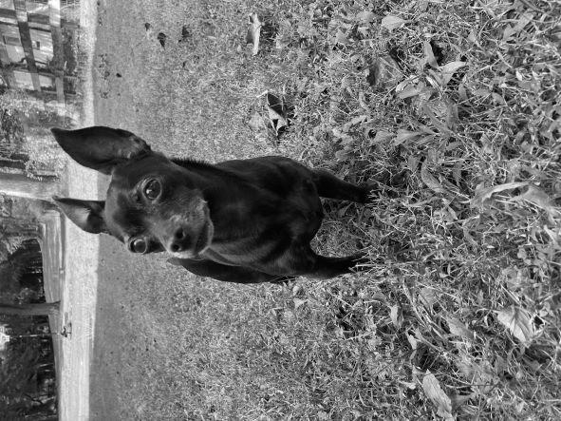

image1:

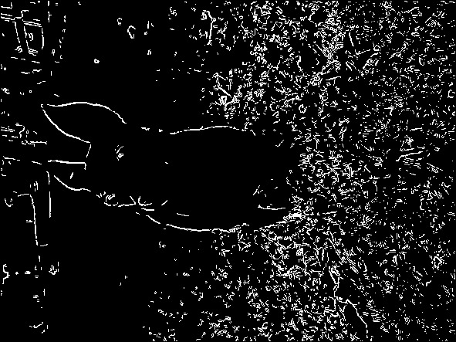

image2:

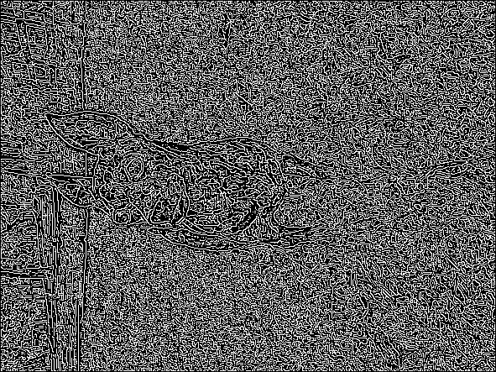

imagef:

